**Deep Learning**

Deep Learning is the most exciting and powerful branch of Machine Learning. Deep Learning models can be used for a variety of complex tasks:

* Artificial Neural Networks for Regression and Classification
* Convolutional Neural Networks for Computer Vision
* Recurrent Neural Networks for Time Series Analysis
* Self-Organizing Maps for Feature Extraction

Deep Boltzmann Machines for Recommendation Systems

* Auto Encoders for Recommendation Systems

Following Deep Learning models are implemented in this tutorial:

1. Artificial Neural Networks for a Business Problem
2. Convolutional Neural Networks for a Computer Vision task

For neural networks to work properly, we need two things –

* Data and I mean lot of data
* Processing power/ Strong computers to process that data

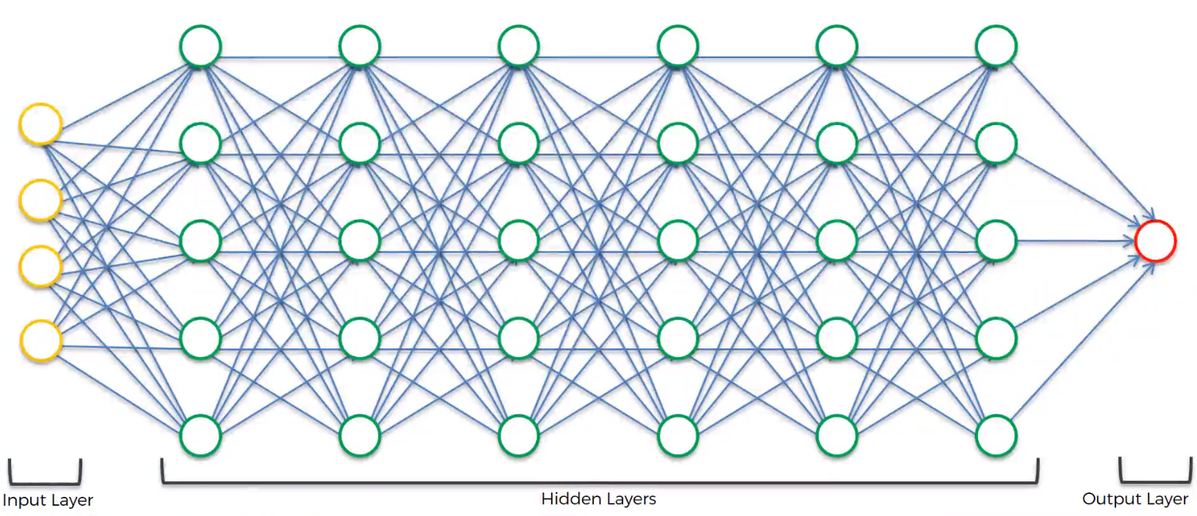

**Artificial Neural Networks –**

* The neuron
* Activation Function
* How do neural networks work?
* How neural networks learn?
* Gradient Descent
* Stochastic Gradient Descent
* Backpropagation

**Neuron Structure –**

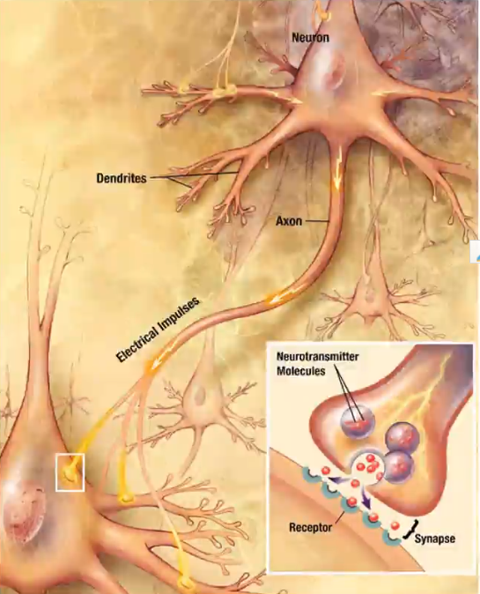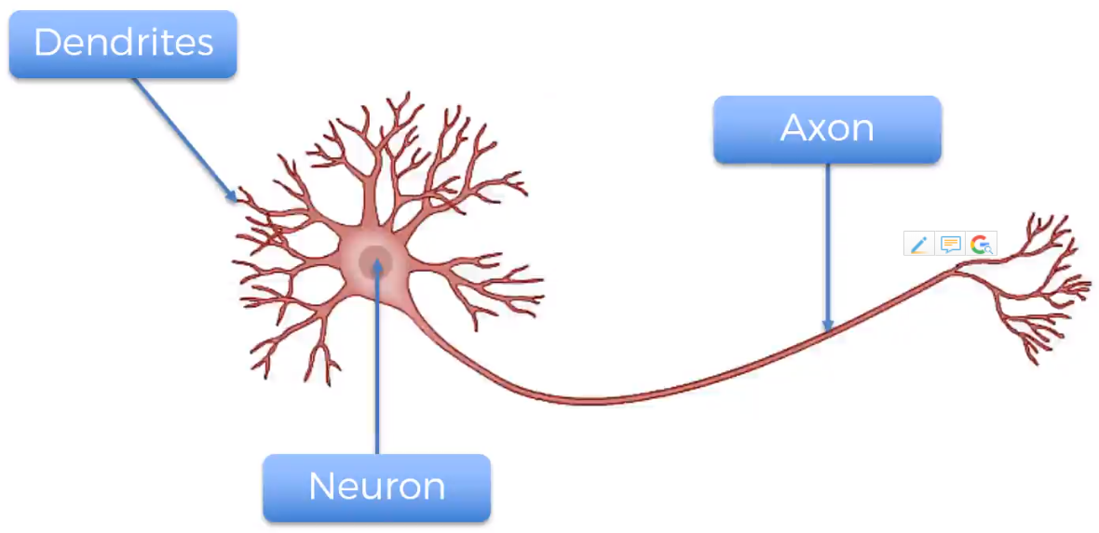

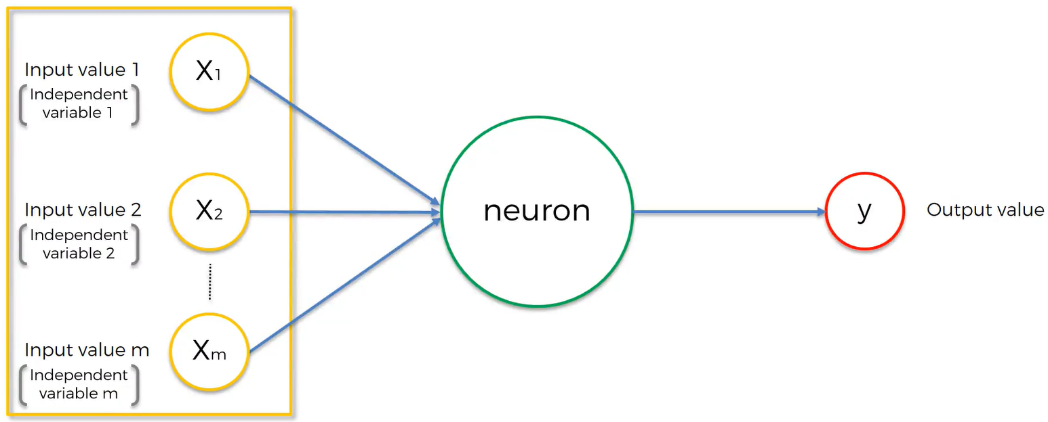

All independent variables are for one single observation. We need to standardize them – mean, median observations or normalize them.

Output variable can be continuous(price), categorical variable (several output variables), binary.

All inputs you put for one row and you get one output for same row/observation.

Weights are how neural networks learn. What signals need to be passed/ relevant data is decided by adjusting the weight values.

Inside neuron, it takes weighted sum of all the input values, then it applies activation function to the sum.

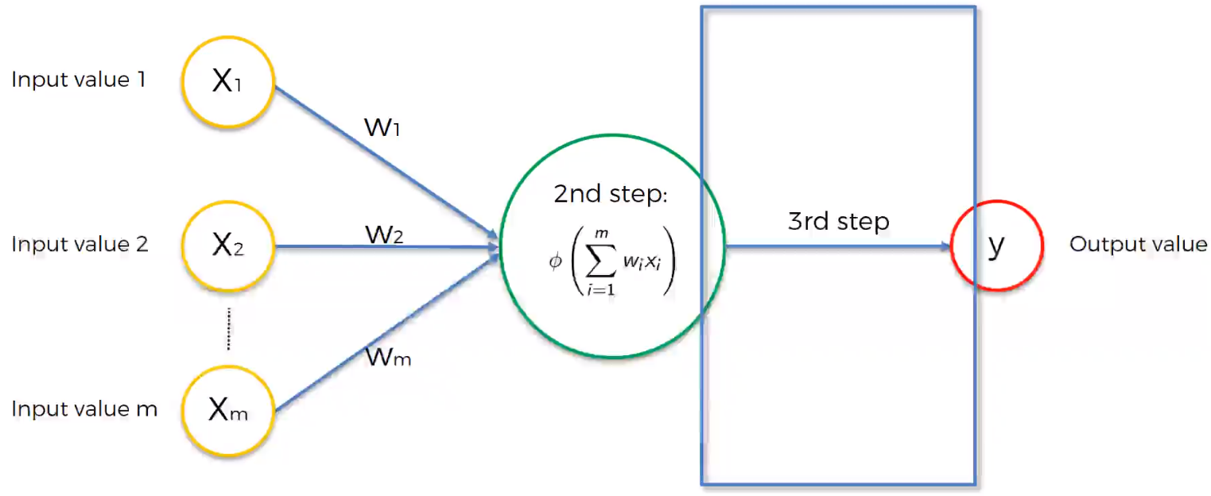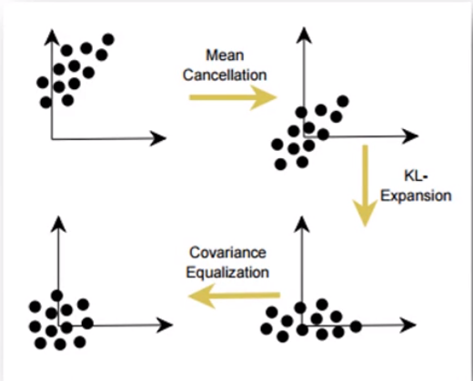

There are 4 distinct types of activation function –

**1. Threshold sum** – Simple function if value is less than 0, the threshold function passes on 0. Else if the value is more than 0, then the threshold function passes on 1. Yes/ No type, rigid type of function.

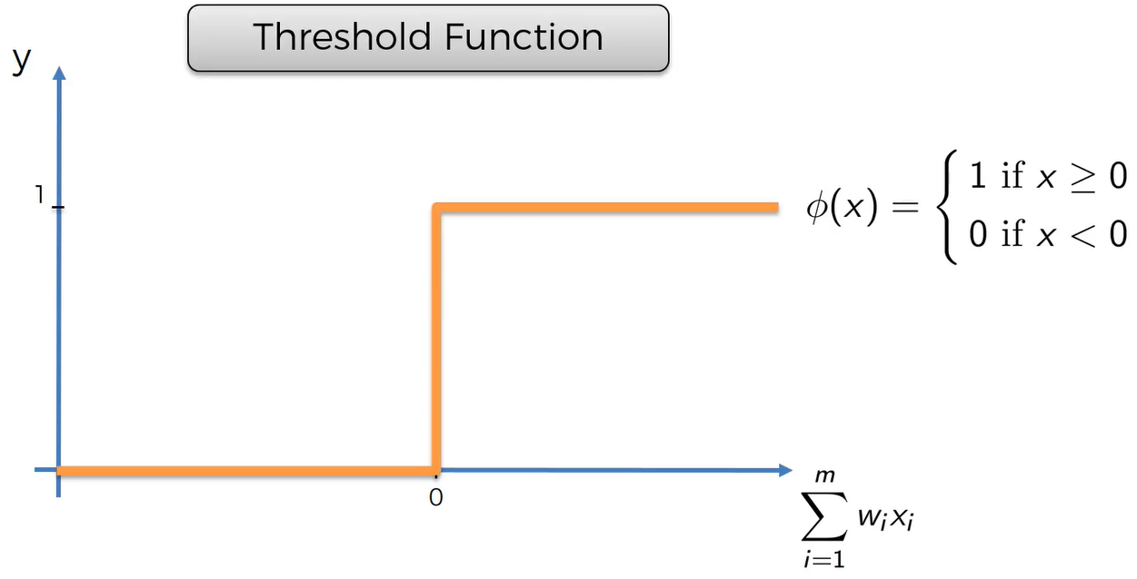

**2. Sigmoid Function –** Used in logistic regression. It has a smooth curve, gradual progression. It is useful in output layer when you are trying to predict probabilities.

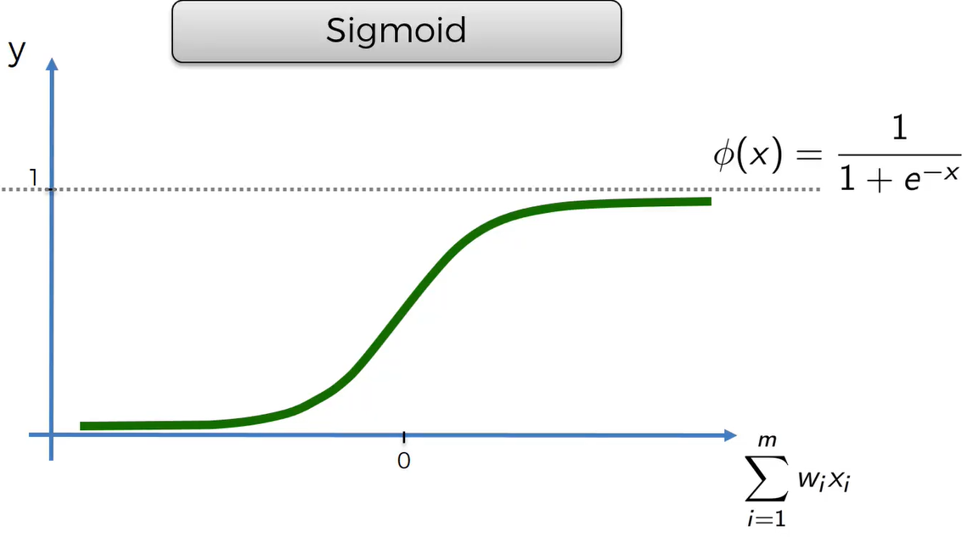

**3. Rectifier function -**

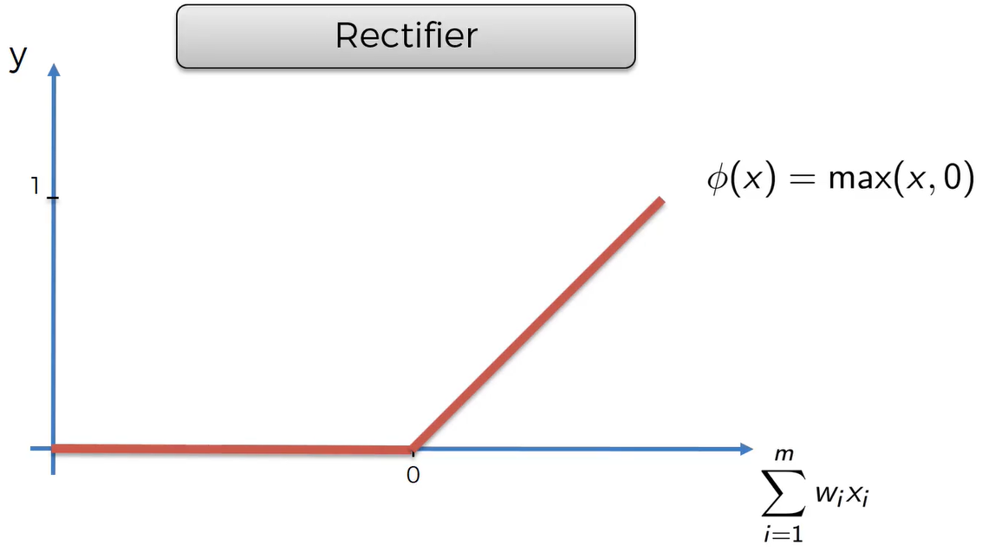

**4. Hyperbolic tan function –**

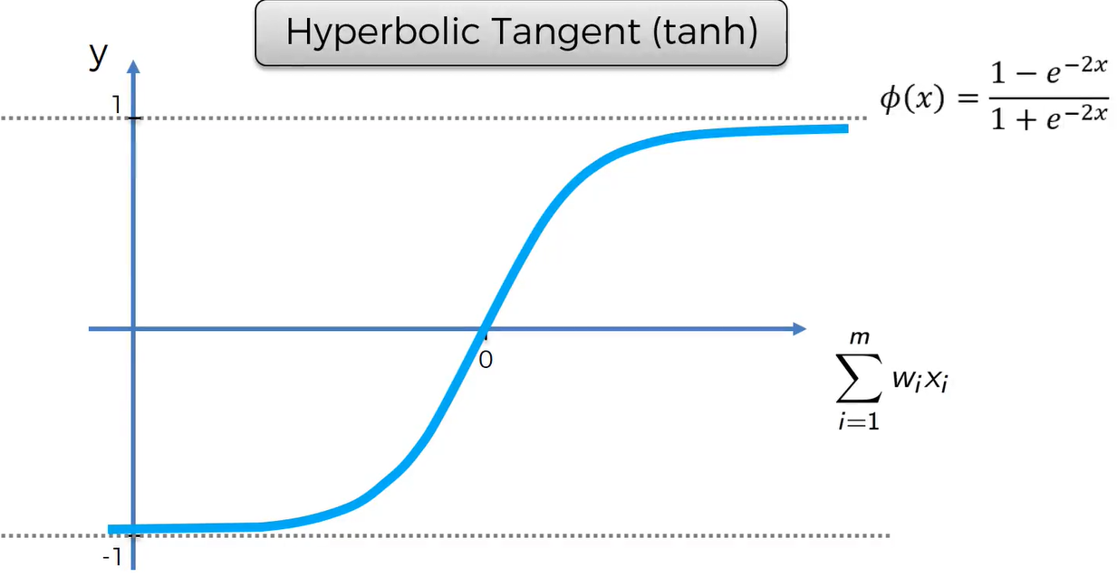

**How Neural networks work?**

Basic form of NN – Only Input layer and output layer.

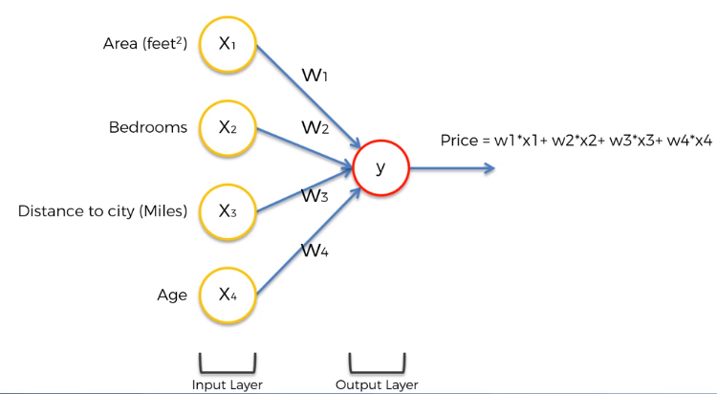

You adjust the weights to get optimum result. Any activation function can be used to calculated weighted sum of inputs.

To increase accuracy, we have hidden layers.

All 4 variables from input layer have synapses connecting to the top neuron of hidden layer. Now these neurons in hidden layer have weights. Some weights will have a non-zero value while some weights will have a zero value (Because not all inputs will be valid for one single neuron, some inputs will be irrelevant). Each neuron will pick up certain set of parameters or combination of parameters.

**Perceptron -**

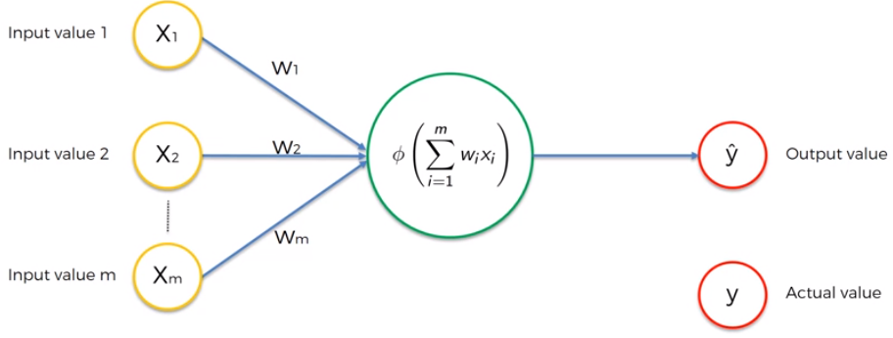

Input values are supplied to perceptron. We calculate cost function to evaluate the model. We tweak the weights based on cost function. Then we compare y hat and y, then again adjust the weights and check the output again. We repeat for the same exact row and minimize the cost function. One epoch is when we go through whole dataset and train our neural network on all of these rows. When we have multiple rows, we get the y hat for all the rows. Then we compare to the actual values. Then we calculate cost function as follows -

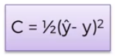 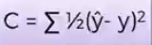 With full cost function, we go back and adjust the weights. These weights are shared by all the rows. This happens in one iteration. The total number of iterations = Total number of observations. This whole process is called back propagation. A list of cost functions used in neural networks –

<https://stats.stackexchange.com/questions/154879/a-list-of-cost-functions-used-in-neural-networks-alongside-applications>

**Single Layer Feed forward network or Perceptron**

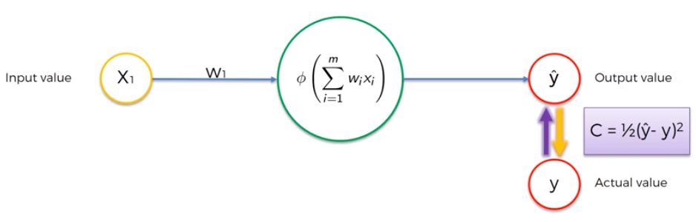

How to minimize the cost function?

Brute force Approach – Take lots of possible weights and see which one works best. But if we increase the number of weights, we will face a problem – **Curse of Dimensionality**.

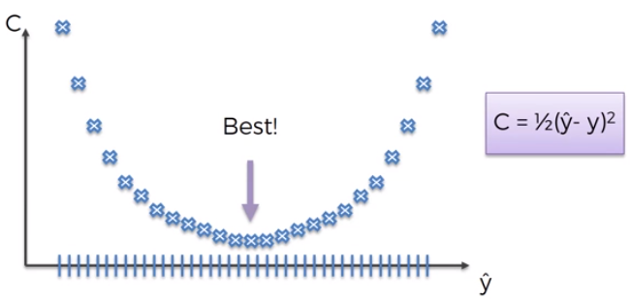

**Gradient Descent -**

Start at a point, check the angle of cost function at that point. Find the slope at that particular point and check if it is positive or negative value. Keep doing this until you get the best weights that minimizes the cost function.

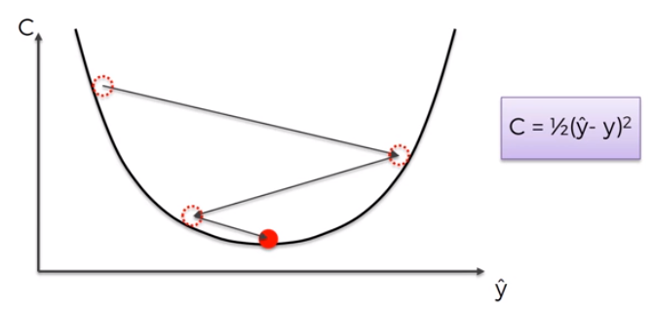

**Gradient Descent in 2D** **Gradient Descent in 3D**

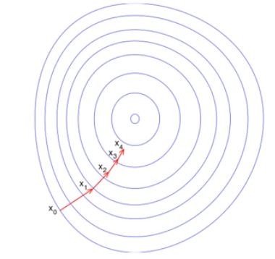 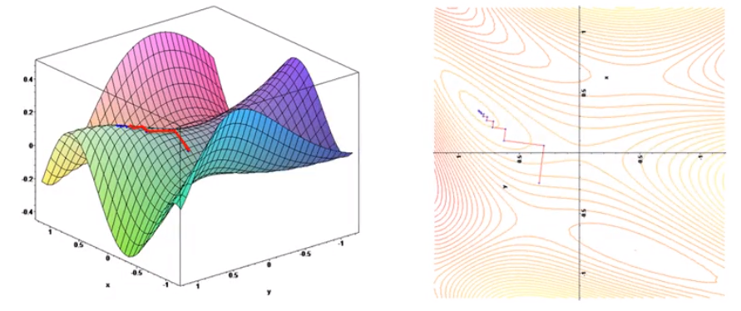

If the function is not convex as shown above (non-convex function). This happens when we choose a cost function that is not as given above or if we do choose the same cost function as above, it might change the shape in multi-dimensional space. Then we find local minimum of function than global minimum and we don’t have optimal values what do we do? Then we use stochastic gradient descent function. In normal gradient descent, we all the rows are plugged into neural network every time. But in Stochastic gradient descent, all the rows are plugged in one by one into the neural network and every time a row is plugged in, the weights are adjusted. Stochastic gradient descent helps us avoid problem where we find the local extremities or local minimums rather than global minimums. It is faster than batch gradient because it doesn’t have to load all the memory to calculate at once. It is random. Batch gradient is more deterministic algorithm. Mini Batch gradient – Combination of both batch gradient and stochastic gradient methods.

<http://neuralnetworksanddeeplearning.com/>

<https://iamtrask.github.io/2015/07/27/python-network-part2/>

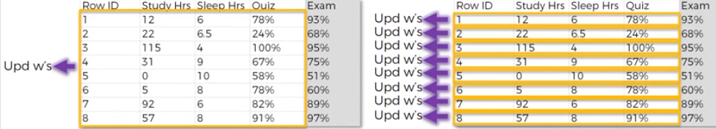

Back Propagation – Allows us to adjust all the weight values simultaneously.

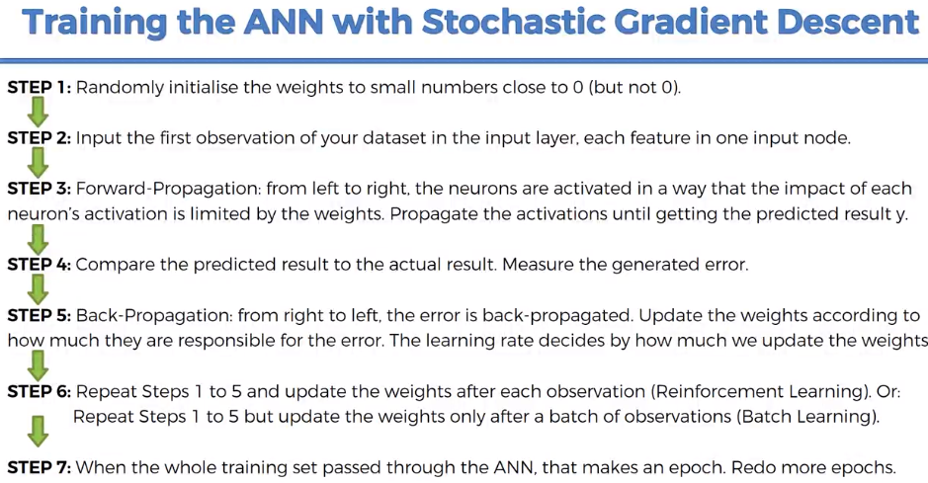

**Installing Theano, Keras and Tensorflow -**

<https://www.udemy.com/machinelearning/learn/v4/questions/4229228>

Higher the value of activation function for the neuron, more impact it will have on the network. The more it will pass on the signal from the nodes on the left to the nodes on the right.

Rectifier function is used here.

No. of nodes in hidden layer = (no. of nodes in input layer + no. of nodes in output layer) / 2

**Convolutional Neural Network –**

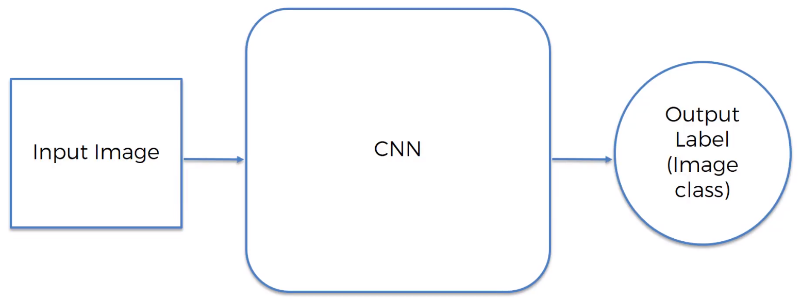

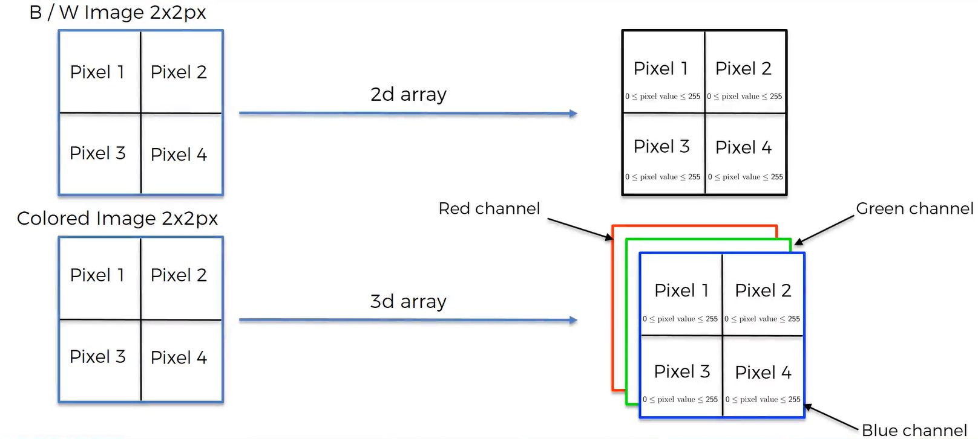

Steps in CNN –

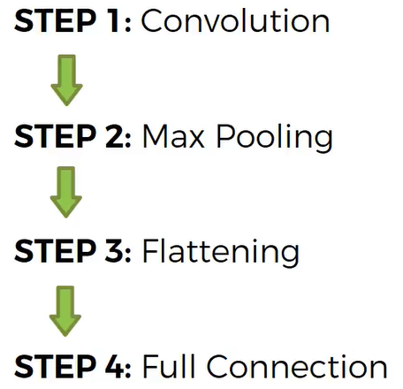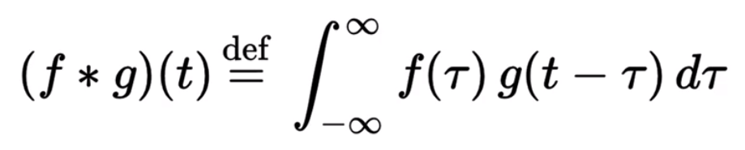

**Convolution function** – Combined integration of two functions and it shows how one function modifies the shape of the other.

[Jianxin Wu Homepage](https://cs.nju.edu.cn/wujx/) - <https://cs.nju.edu.cn/wujx/>

Feature Detector/ Kernel/ Filter

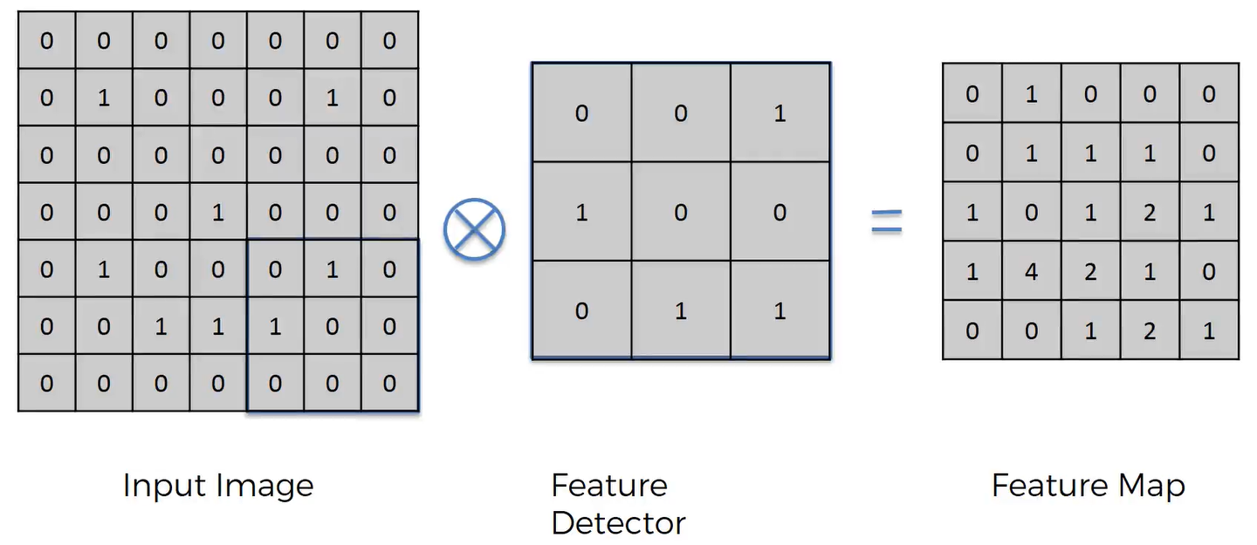

We have reduced the size of the image. This convolution step makes the image size smaller and helps to process it faster. The stride is 1 pixel here. We multiply 3 * 3 = 9 pixels with the same corresponding position from feature detector. It encodes features – eyes, nose, hat. Feature Map although we loose some information, helps in preserving features. We use multiple feature detectors to create many feature maps and we get our first convolutional layer. We create multiple convolutional layers and this is how we preserve the loss in information. Using training data, it decides which feature detectors/ filters to use and applies those

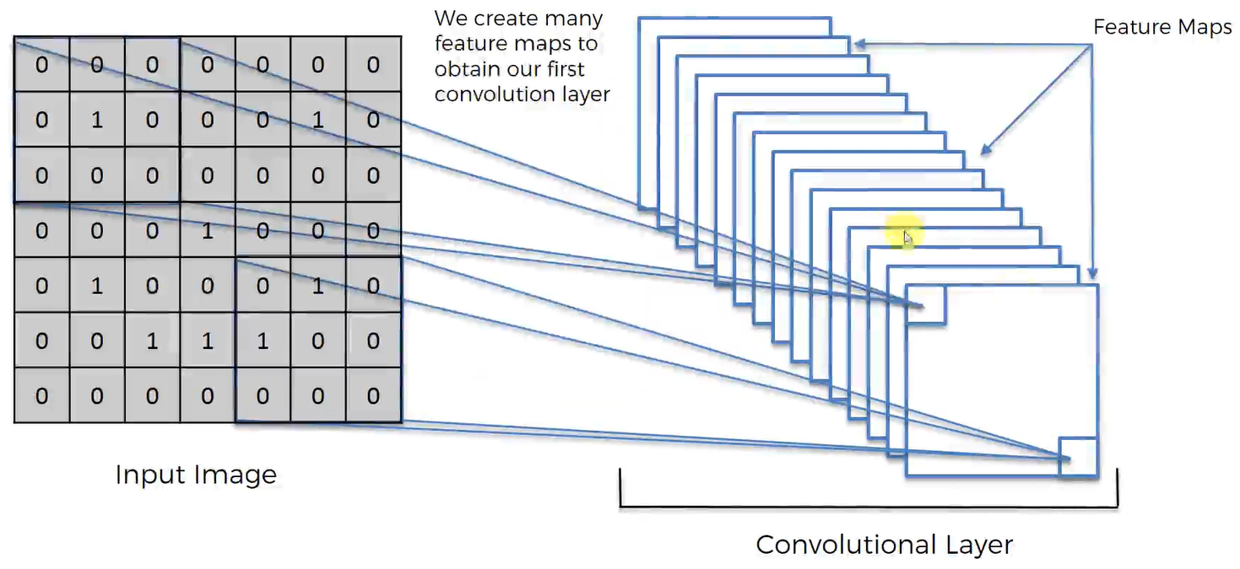

Different versions of Taj Mahal images depending on different feature detectors –

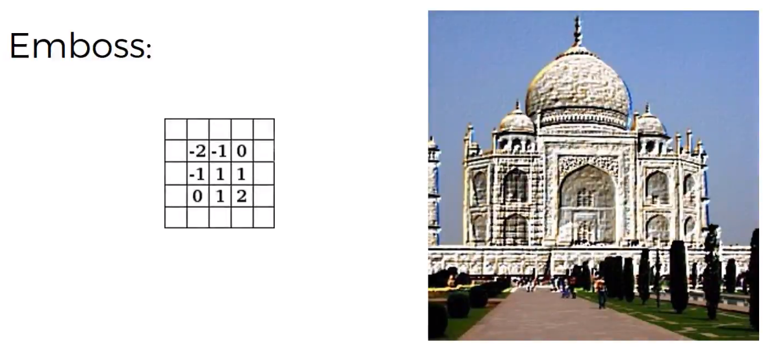

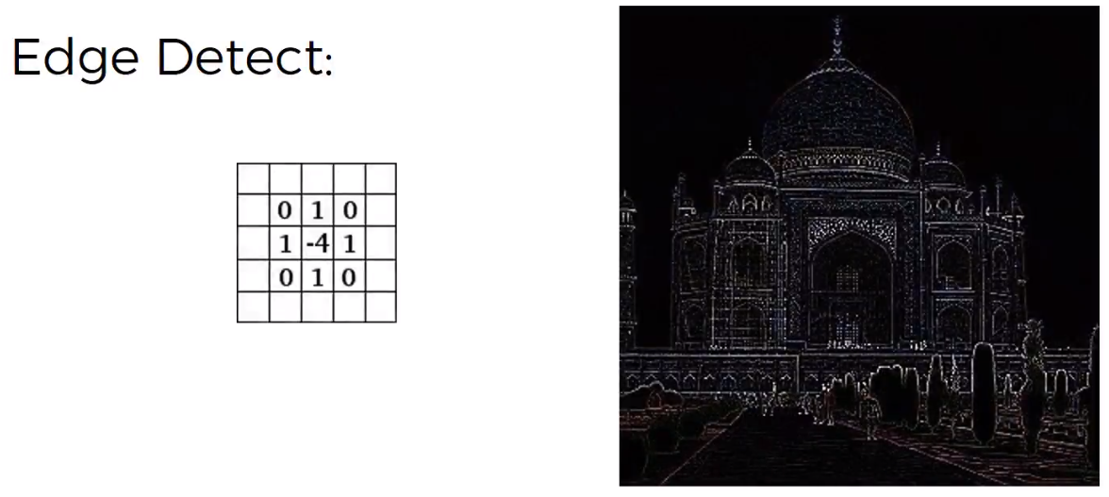

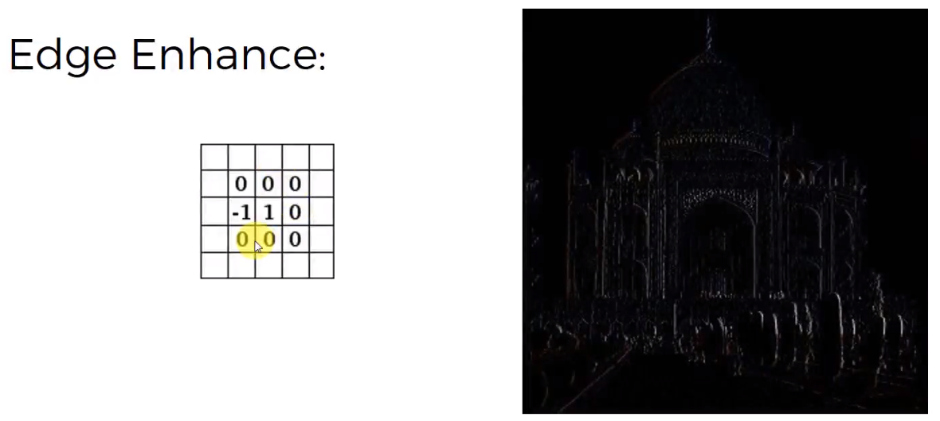

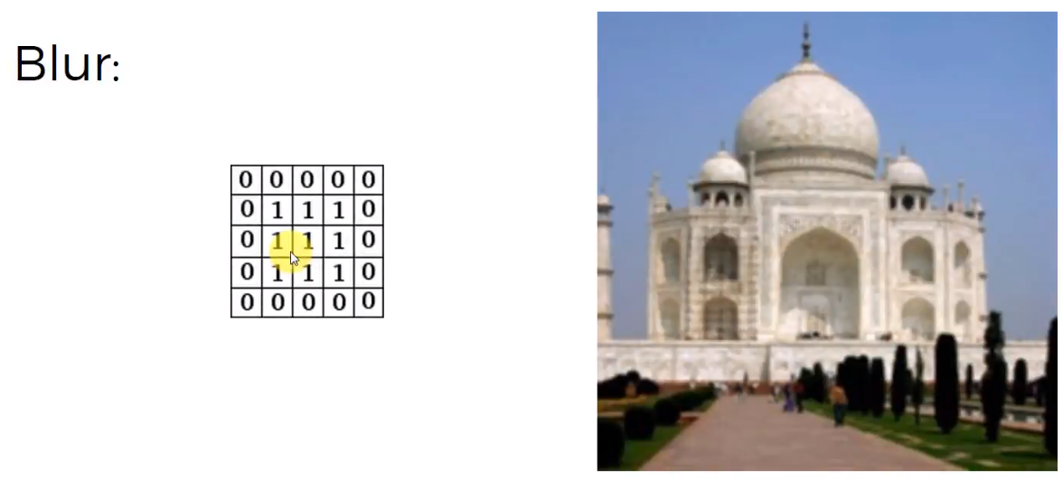

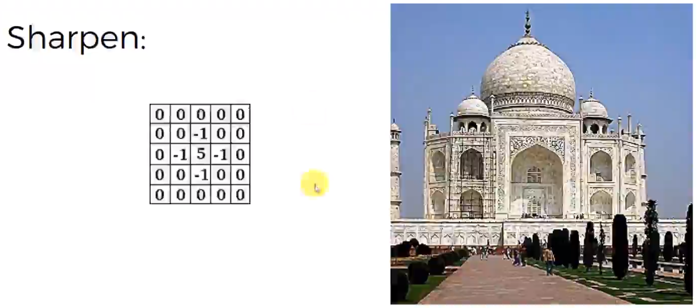

**ReLU Layer -**

Rectifier layer breaks up the linearity and introduces non-linearity to the network. All images have non-linear colors.

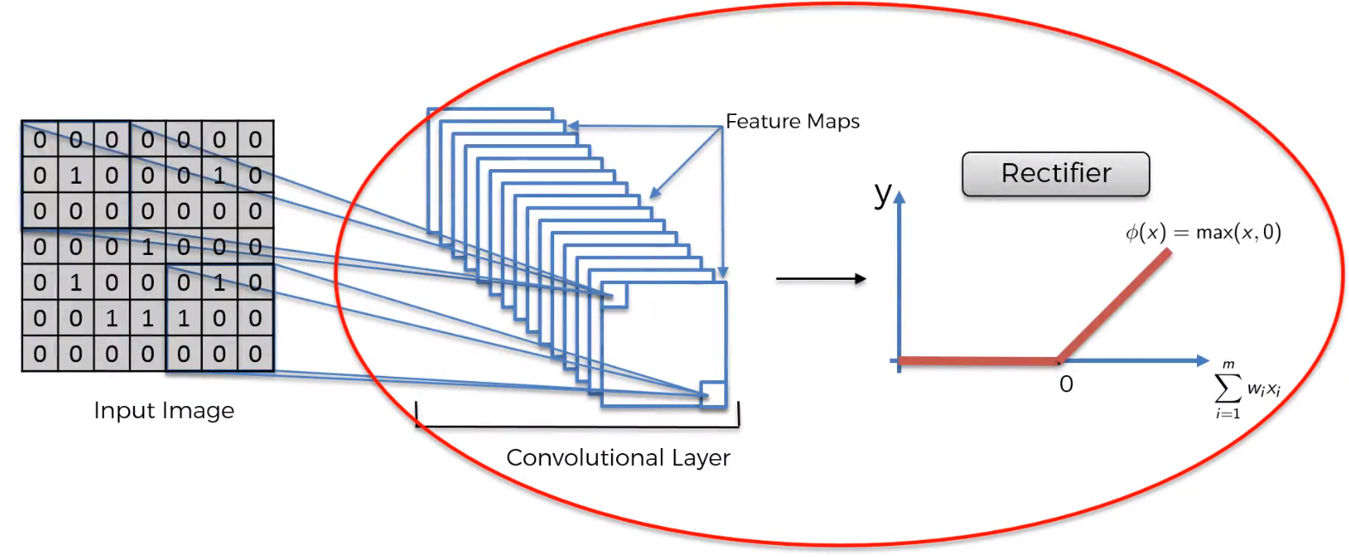

**Max Pooling -**

Neural network should have a property called – Spatial Invariance. It means it doesn’t have to care if the features are a bit tilted, skewed, a bit different in texture relative to the training data, or it is distorted. So, our neural network has to be flexible to find out the features in case it is slightly different. This is where pooling comes into picture. There are different types of pooling – min pooling, max pooling, sum pooling.

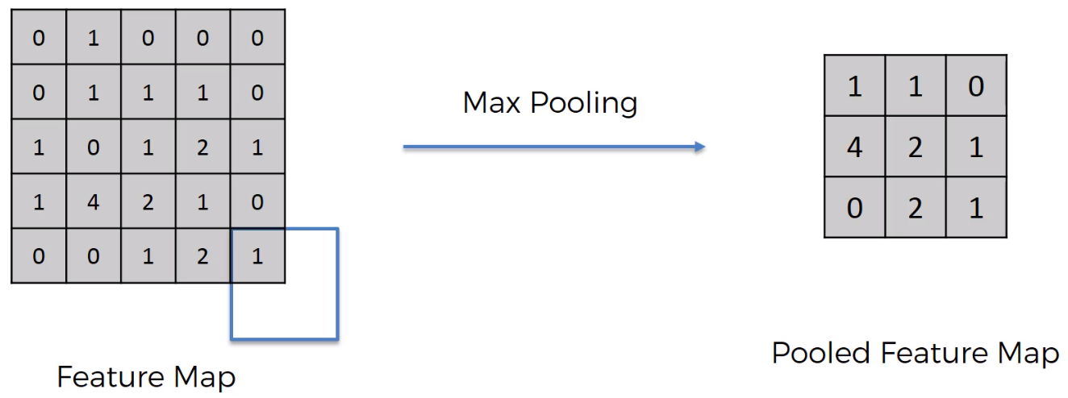

Stride is 2 pixel. We are preserving the features while reducing the size. And we are reducing the final number of parameters that will go into layers of CNN. Thereby preventing over-fitting.

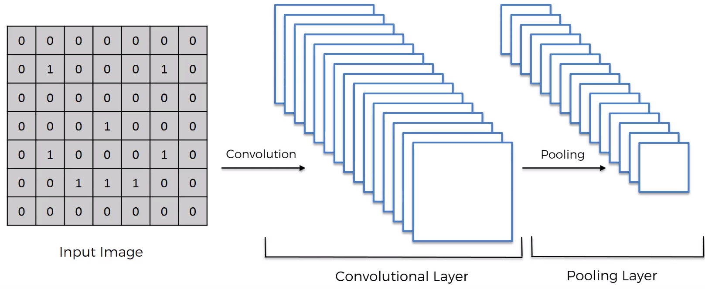

**Flattening –** Taking the pooled feature map and convert it to a column. You get vector of inputs to feed into CNN.

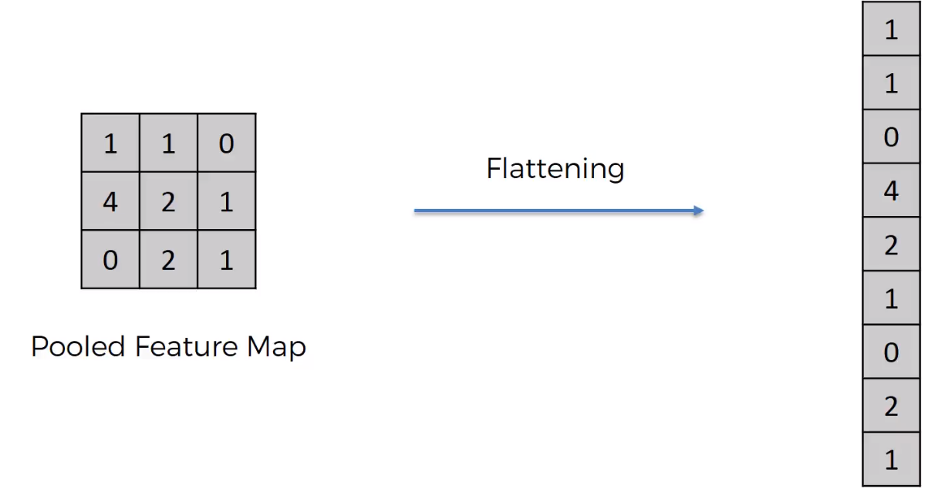

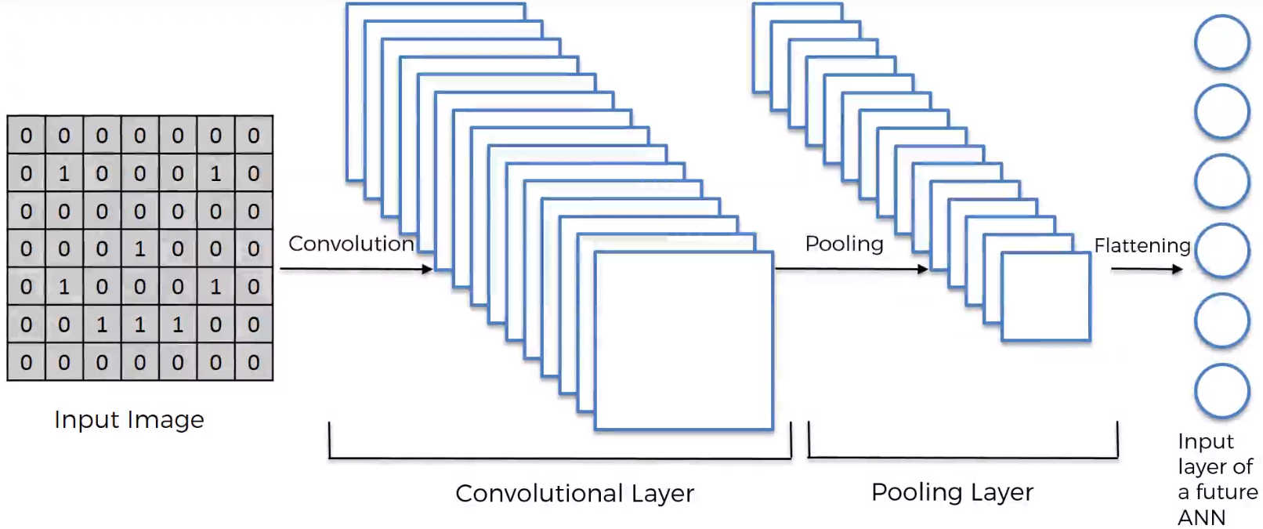

**Full Connection –**

Adding a whole new ANN to the CNN. In ANN, hidden layers need not be fully connected. But in CNN, the hidden layers need to be fully connected.

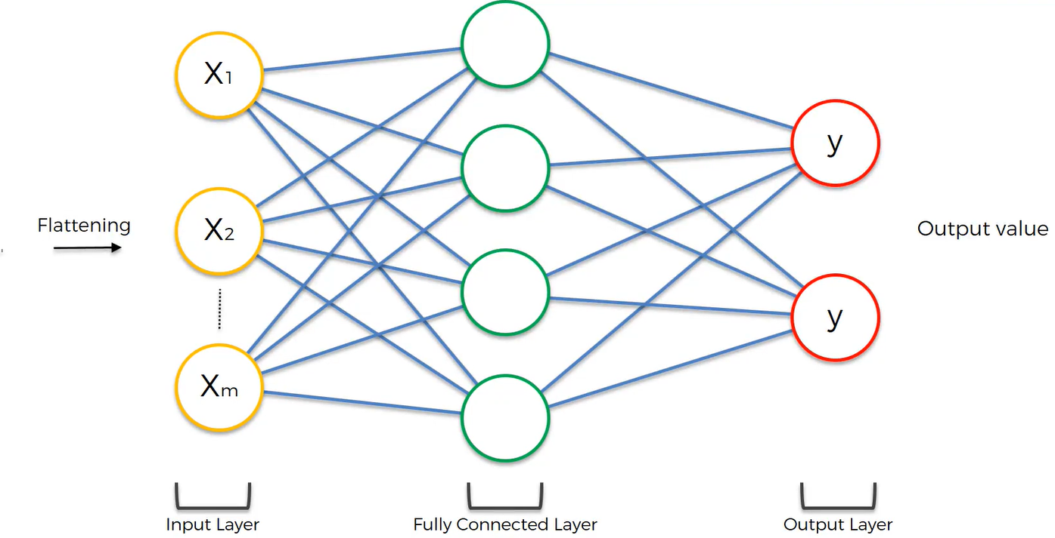

We pass the whole column of vector after flattening onto the Artificial Neural Network as input layer.

If we are having multiple categories in output, then we need one neuron per category. Entropy function is used in CNN as loss function to improve the performance of the model. We minimize that function to optimize the network. We calculate the loss function value and it is then back propagated to the network and some weights are adjusted in the network to help optimize the performance of the network. Another thing that is adjusted is feature detectors.

**Summary –**

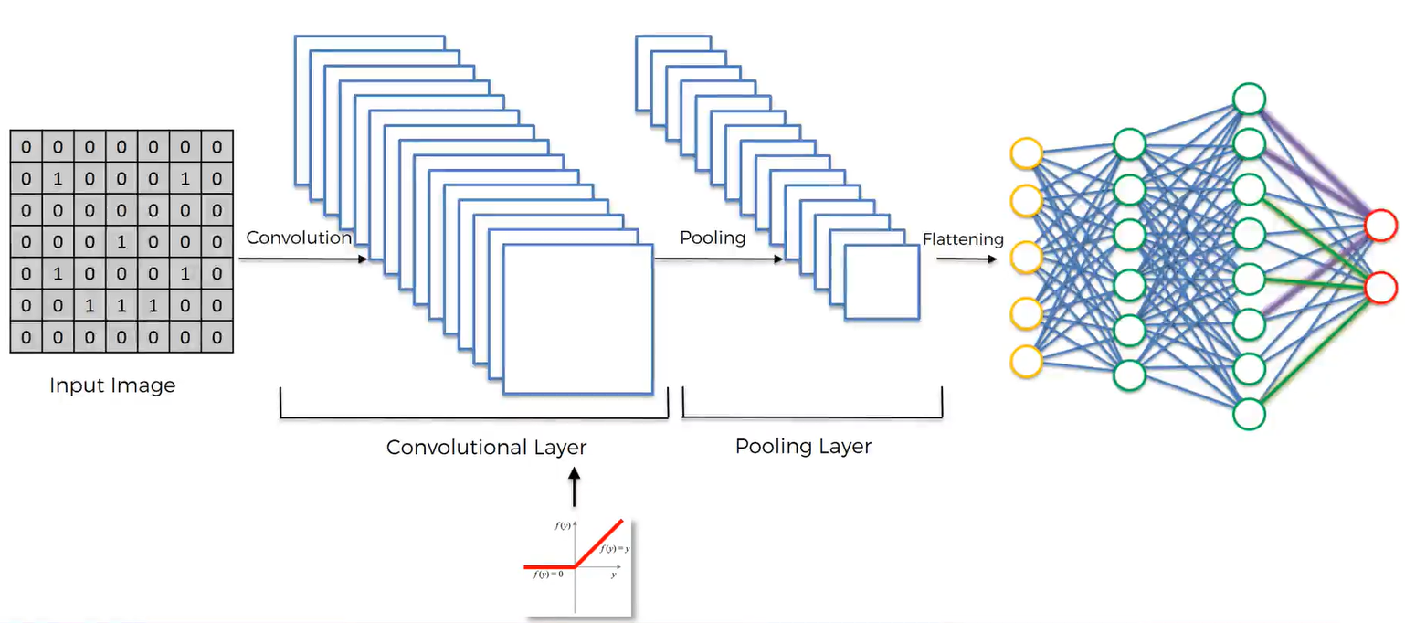

1. We begin with an input image to which we apply multiple feature detectors (filters) to create feature maps. This comprises of our convolutional layer.

2. On top of that convolutional layer, we apply ReLU (Rectified Linear Unit) to remove any linearity and increase non-linearity in the images.

3. Then we apply pooling layer to our convolutional layer. From every single feature map, we created a pooled feature map. Advantages of pooling layer – spatial invariance. If something tilts, twists and is different from the ideal scenario, we can still pick up those features. Pooling significantly reduces the size of the images. Also, since it simply gets rid of lot of unnecessary information, pooling prevents the over fitting of the model to the training images.

4. Then we flattened all of the pooled images into one long vector or column of values and we input it into artificial neural network.

5. We have fully connected artificial neural network where all of these features are processed through the network and we have one fully connected final layer that performs voting towards different classes.

6. All of this is trained through a forward propagation and backward propagation – lots and lots of iterations and epochs. Then we have a very well defined neural network.

6. Parameters that get adjusted are – weights and feature detectors.

[9 Must deep learning papers](https://adeshpande3.github.io/The-9-Deep-Learning-Papers-You-Need-To-Know-About.html) - <https://adeshpande3.github.io/The-9-Deep-Learning-Papers-You-Need-To-Know-About.html>

**Softmax and Entropy -**

Softmax function makes sure that the sum of probabilities of output neurons after classification is equal to 1.

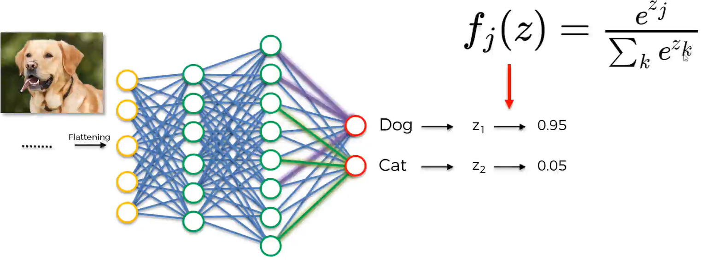

Cross – Entropy function – In CNN, loss function is cross entropy function. We minimize this function to maximize the performance.

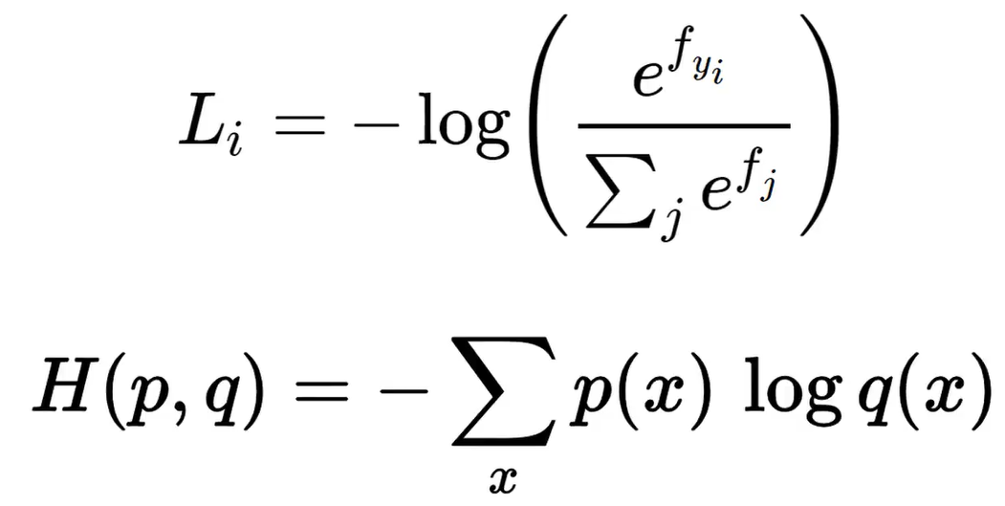

Comparing two neural network models –

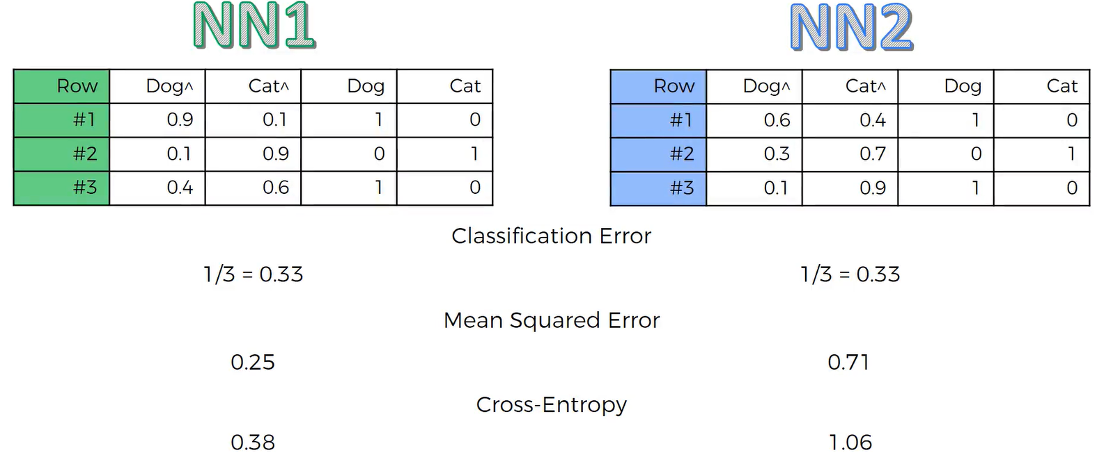

For more info on cross-entropy loss –

1. [A friendly introduction to cross-entropy loss by Rob Pietro](https://rdipietro.github.io/friendly-intro-to-cross-entropy-loss/)

2. [How to implement a neural network intermezzo 2](http://peterroelants.github.io/posts/neural_network_implementation_intermezzo02/)

Feature scaling is compulsory for deep learning models especially Computer Vision.

**Image Augmentation –**

1. When we have new data in the training set, to predict it’s category, the model finds some correlations in the few observations in the training set but it fails to generalize these correlations on some new observations. When it comes to images, we need a lot of images to find and generalize some correlations because it needs to find some patterns in the pixels. To get great performance results, we either increase the number of images or use a trick. We use data augmentation here, what it does is, it creates many batches of the images and then on each batch, it applies some random transformations on a random selection of image like rotating them, flipping them, shearing them and shifting them. So eventually, we get many diverse images during the training inside these batches and lot more material to train. Since the number of training images is augmented, it is called **image augmentation**. And the transformations are random, so the model will never find same picture across batches.It will reduce over fitting.

**Dimensionality Reduction –**

There are two types of Dimensionality Reduction techniques:

1. Feature Selection
2. Feature Extraction

Feature Selection techniques are Backward Elimination, Forward Selection, Bidirectional Elimination, Score Comparison Feature Extraction techniques:

1. Principal Component Analysis (PCA)
2. Linear Discriminant Analysis (LDA)
3. Kernel PCA
4. Quadratic Discriminant Analysis (QDA)

PCA Applications – Noise filtering, visualizations, feature extraction, stock market predictions, gene data analysis.

PCA Goal –

1. Identify and detect strong correlation between variables

2. Identify patterns in data

PCA is to reduce the dimensions of a d-dimensional dataset by projecting it into a k dimensional subspace (k < d)

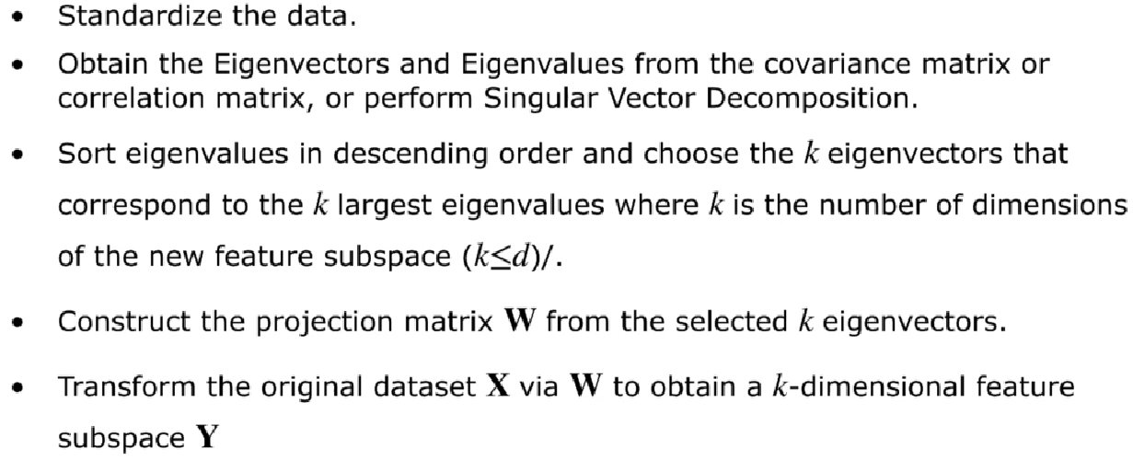

For more info, refer the [plotly link](https://plot.ly/ipython-notebooks/principal-component-analysis/) and [visual explanation of PCA by setosa](http://setosa.io/ev/principal-component-analysis/) .

1. Learn the relationship between X and Y values.

2. Find list of principal axis

3. It is highly affected by outliers in the data.

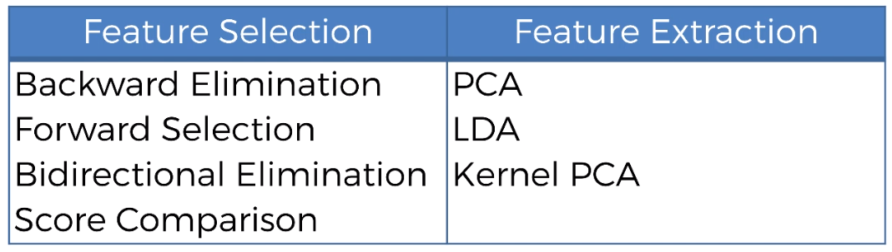

From m independent variables of the dataset, PCA extracts p≤ m new independent variables that explain most of the variance in dataset regardless of dependent variable. The fact that Dependent Variables in not considered makes PCA an unsupervised learning model.

PCA is totally used for supervised learning models, but it is itself an unsupervised learning tool.

PCA itself is an unsupervised algorithm. i.e the target variable y never plays a role in deciding the PCA output for x. The classification which follows the PCA fits the compressed data to y.

**Linear Discriminant Analysis –**

1. Commonly used in dimensionality reduction.

2. Used in preprocessing step for pattern classification.

3. Projects dataset onto lower dimensional space.

Although LDA is similar to PCA in finding the component axis, LDA also finds the axes that maximizes the separation between multiple classes.

LDA projects a feature space (a dataset of n-dimensional samples) onto a small subspace k (k ≤ n-1) while maintaining class discriminatory information. Unlike PCA which is unsupervised, LDA is a supervised algorithm because it makes use of dependent variable.

For more info on LDA, refer the link by [Sebastian Raschka on LDA](https://sebastianraschka.com/Articles/2014_python_lda.html).

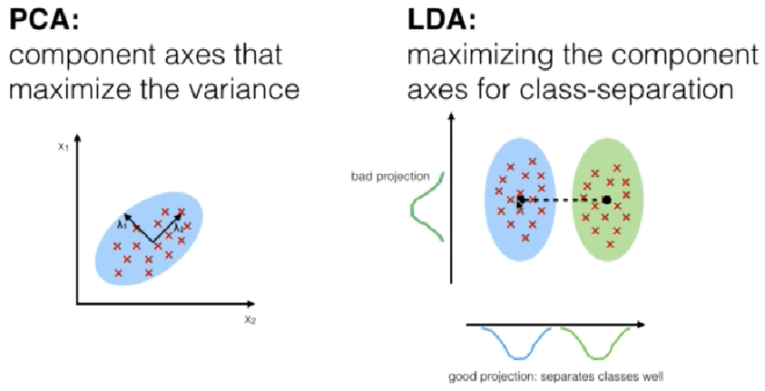

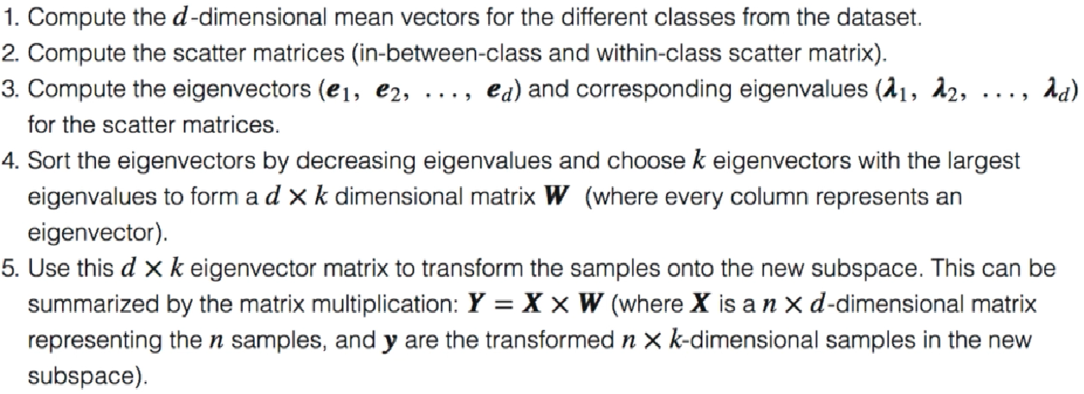

From the n independent variables of the dataset, LDA extracts p ≤ n new independent variables that separate most of the classes of the dependent variable. So, LDA is a supervised model.

PCA and LDA are used for linearly separable data.

For non-linearly separable data, we use **kernel PCA.**

Kernel PCA is kernelized version of PCA where we map the data to a higher dimension using kernel trick and take data to a new feature space where it is linearly separable and then from there you extract new principal components that explain most variance.

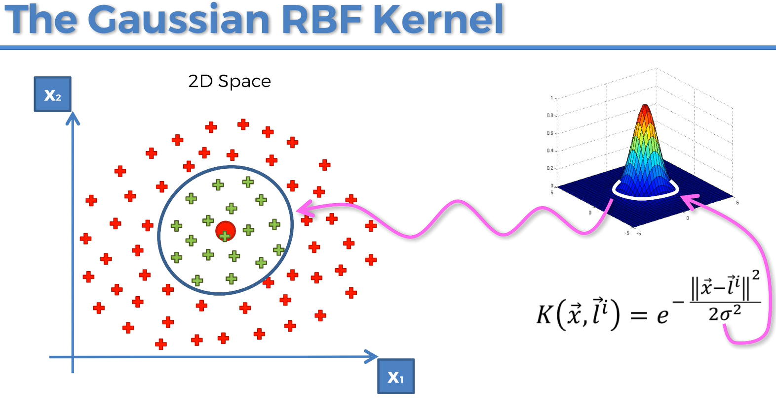

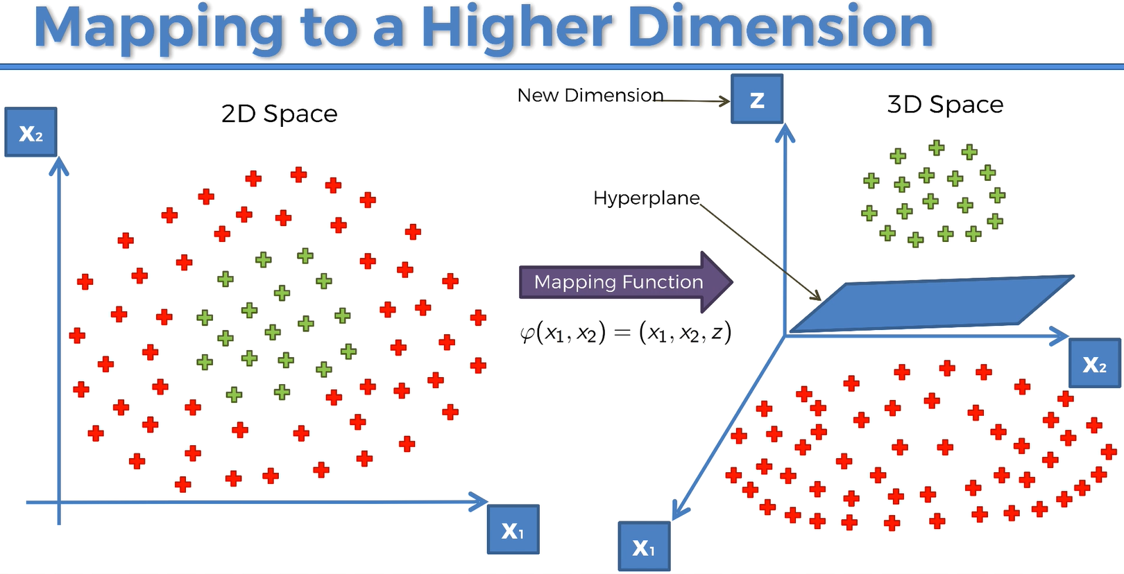

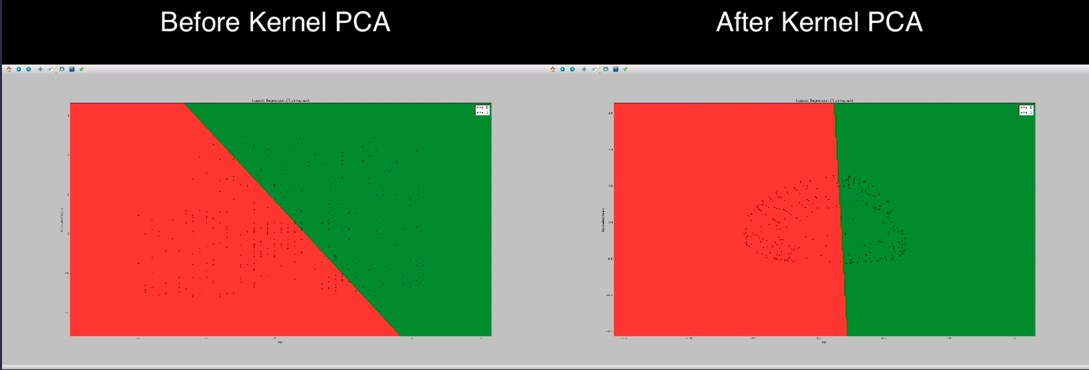

**Model Selection and Boosting -**

1. How to deal with the bias variance tradeoff when building a model and evaluating its performance?
2. How to choose the optimal values for the hyperparameters (the parameters that are not learned)?
3. How to find the most appropriate Machine Learning model for my business problem?

To improve model performance, we need to consider best parameters. There are two types of parameters that are present in machine learning models –

1. Parameters that the model learnt, parameters that were changed to find optimal values by running the model

2. Parameters that we chose ourselves. Ex – The kernel parameter in the kernel SVM model. These parameters are called the hyper-parameters. We need to choose optimal values to the hyper-parameters.

Splitting the dataset into training set and test set will have variance problem. When we test the model on test set we get a accuracy value, when we test the same model on a different test set, we get a different accuracy value. So, judging the model based on the accuracy of a single test set is not right. That is not the right way to evaluate model performance.

K-Fold Cross validation will remove this variance problem and increases the accuracy.

**K-Fold Cross Validation -**

If k = 10, it splits the training set into 10 folds. It will train the model on 9 folds and test it on 10th fold. There are total 10 combinations of training and test set in 10 fold model. We can have 10 iterations of original training set split into 10 folds. It will give much better idea of model performance. We can take average of the accuracies of 10 different sets, and calculate the standard deviation to look at the variance. So, analysis will be much more relevant.

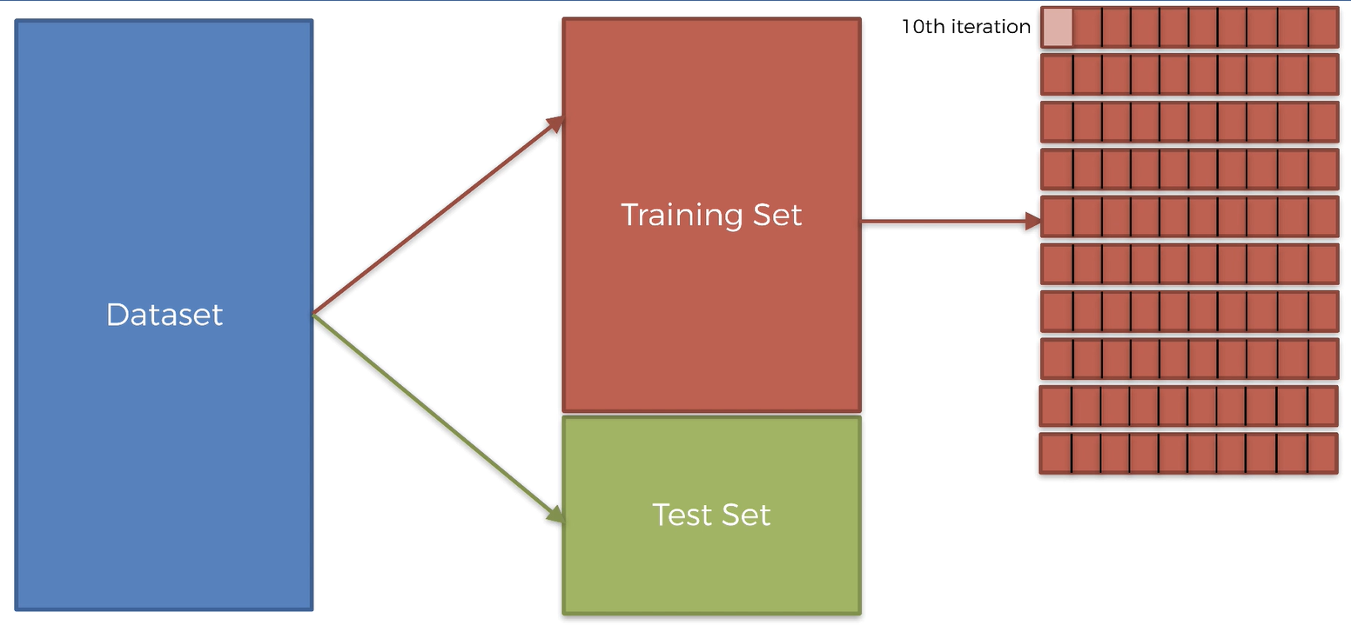

Based on accuracy and variance, there are 4 categories –

1. High Bias Low Variance (Bias is nothing but accuracy)

2. High Bias High Variance

3. Low Bias Low Variance

4. Low Bias High Variance

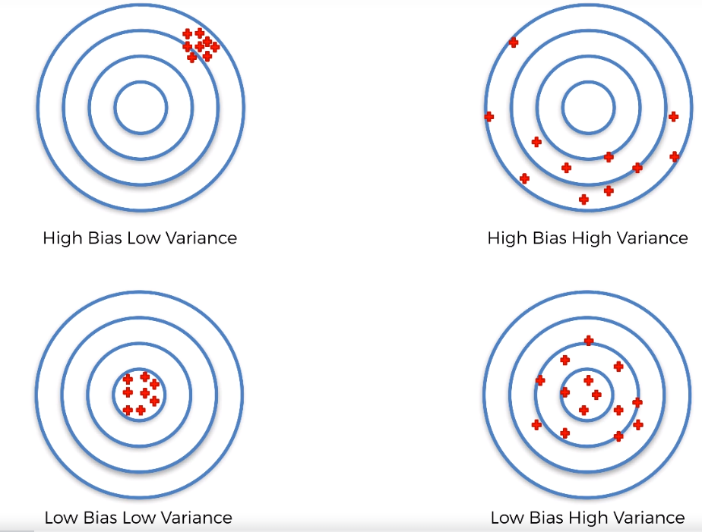

K-Fold cross validation is applied right after we build the model.

**Grid-Search Technique** is another model for evaluating the performance of a model. It searches for optimal values for hyper-parameters in machine learning models.

Which model should I choose to solve my business problem?

1. Decide if the problem is a regression problem, or classification problem or, clustering problem.

Check if you have a dependent variable, if you don’t have a dependent variable, then it is a clustering problem. If you have a dependent variable, then check if the outcome is continuous or categorical. If you have continuous outcome, then the problem is a regression problem. If the outcome is categorical, then the outcome is a classification problem.

2. Decide if the problem is a linear problem or non-linear problem, especially when you have large dataset. If your data is really large, then you are confused whether to choose linear model like SVM in case of classification or non-linear model like Kernel SVM. Then the grid search technique will answer how to choose the method.

We optimize the values of hyper-parameters using grid search.

For more info on Caret Package – click [this GitHub link](http://topepo.github.io/caret/available-models.html).

We use caret package for parameter tuning.

**Difference between Random Forest / K-Fold Cross Validation and Grid Search –**

The random forest model will create a forest or many types of decision trees that it sums together to get one good prediction. It is taking weak learners and putting them together to make one strong learner.

The k-folds cross validation methods is somewhat similar to grid search, because sometimes it is used to find optimal parameters. Cross-validation is mainly used to get a realistic model accuracy, but making different splits of train and test data and applying that to the model. Splitting the data a certain way with the same model can alter the accuracy slightly, so it's good to take the average of the cross-validation to get an representative accuracy of your model.

Grid search is used to find the optimal parameters for your model. You simply pick a range of parameters you would like to try in your model, and see what values provide the best accuracy.

In summation:  
Random Forest: Combining many decision trees together for one string prediction.  
Cross-validation: Repetitive execution of model with different train and test data to obtain realistic accuracy. Grid Search: Repetitive execution of model with same train test data, but different model parameters to obtain optimal parameters.

**XGBoost (Gradient Boosting model with decision trees) –** Most powerful implementation of Gradient Boosting in terms of model performance and execution speed.

XGBoost is one of the best model in terms of performance – accuracy and execution speed for large dataset. Feature Scaling is not required for XGBoost.

To learn more about XGBoost - <https://www.hackerearth.com/practice/machine-learning/machine-learning-algorithms/beginners-tutorial-on-xgboost-parameter-tuning-r/tutorial/>